**Cycles, Nodes, and Modes– Unit 2**

Corey Crooks

Purdue University Global

IT302—Human Computer Interaction

Theodore Witt

September 7, 2022

**Part 1**

Norman’s execution/evaluation cycle has seven main parts to it: establish the goal, form the intention, specify the action sequence, execute the action sequence, perceive the system state, interpret the system state, and evaluate the system state concerning goals and intentions (Reinecke, 2022). For example, the steps could be followed reasonably well with the following heuristics: establish the goal of waking up. Form the intention to make a cup of coffee. Specify the action sequence of walking to the coffee maker, preparing grounds, turning on the machine, and brewing the coffee. Execute these actions to the best of your ability. Perceive the system state of drinking fresh coffee. Interpret the system state of the machine working properly to receive the coffee grounds, and infuse water into them to brew fresh coffee (if the coffee tastes wrong, this would be the step to interpret mistakes and errors). Evaluate the system state concerning goals and intentions by feeling revitalized over the next 15 to 20 minutes.

**Part 2**

The device described herein shall be the Samsung Galaxy Note 8 Smartphone. This device is meant as a productivity smartphone that has an integrated stylus called the ‘s pen’ that serves to further assist the user in their productive life. Given that this device is a smartphone, it is capable of web browsing, phone calls, photography and videography, and much more.

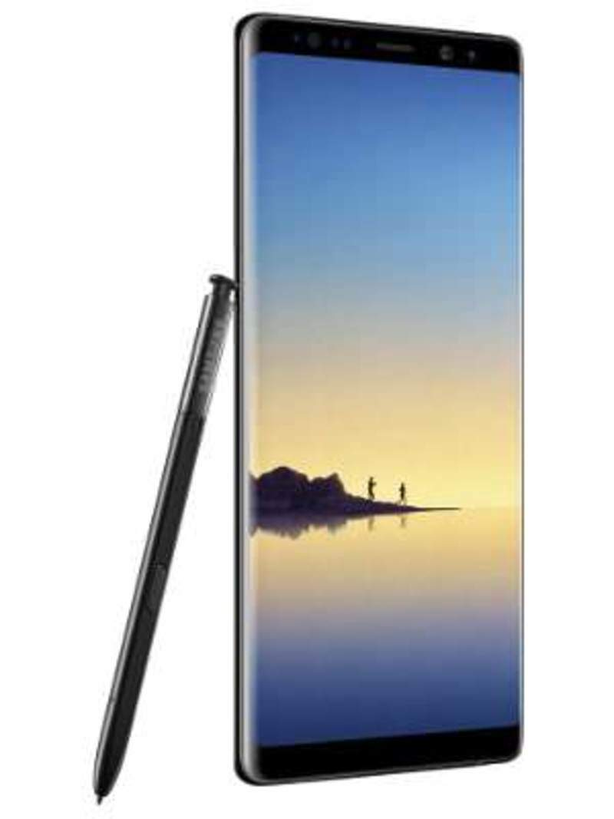Figure 1. *Samsung Galaxy Note 8.* 2022

Possible actions on this device can be both simple and difficult to understand. For example, actions such as calling and texting are immediate and responsive. Thanks to the touchscreen on the device, the user can navigate menus and open desired apps with ease. On the other hand, navigating the settings to turn off unwanted features such as some developer-only accessibility options can be a relative challenge. Some settings are hidden behind a soft lock that the user must tap an icon a certain number of times and enable a prompt to access. The mappings from intention to physical movement follow a somewhat simple process. Since the primary input method on such a device is the touch screen, the user does not need to handle navigation buttons or analog sticks to move a cursor. This provides a level of clarity that isn’t seen in traditional input methods. Additionally, volume and power buttons are featured on the sides of the device. For the volume controls, one long button is present that has a south action and a north action to turn the volume down and up respectively. Although this may be pleasing for design philosophies, a single button with two actions presents a sort of complication with immediate recognition.

For novice users, this device may seem somewhat appealing. The touchscreen inputs provide an easy heuristics-generation style as well as an added styles for handwriting that is built into the smartphone itself. The relationship between user and system level states is not easy to fall out of synch until more advanced actions are required such as installing rootkits, manipulating advanced settings, and using peripherals like controllers and keyboards. Some confusion that may arise, however, is the aforementioned buttons on the sides. A novice level user will need to commit each button, its location, and its function to memory to be effective with this device. This memorization is even more confusing with the Bixby key below the audio rocker. Upon accidental presses, the Bixby key will lead users to a slow and unresponsive layout similar to that of Google News. In the time since the phone was released, Bixby has been discontinued, and the functionality of this layout has been greatly diminished. Due to this, a user may even find the inclusion of the Bixby button to be a detriment to the overall usability of the device.

**Part 3**

The gulf of execution is a discipline that describes the relationship between a user’s understanding of a current system about the real-world happenings of a system. For example, a user may be using their computer to play Halo Infinite, a popular first-person shooter. During this play session, the user may look at their challenges and see 4 out of 12 for their current progress. This gulf of execution would be relatively elegant should this progress be consistent with the system’s interpretation. If the UI element was designed poorly, which is a common problem in the game, then it may display 4 out of 12 but register 6 out of 12. In this case, the gulf of execution needs proper work to convey the player’s stats in a more accurate light.

**Part 4**

Mental modes can be similar to gulf evaluations. In this, a mental mode describes the user’s preconceptions surrounding a UI element and what it should do. Should the user’s mental mode be mismatched with the function of the UI element, then the user may become frustrated, and the user experience could be greatly impacted in proportion to how prominent that feature is in their experience. Due to the commonality of digital interfaces, consistent design becomes increasingly important. Users need to be able to navigate their experiences with efficacy and ease; these traits are not possible if the user must re-learn everything they know surrounding UI design and common elements. For example, a button labeled “Home” on a website commonly will take you to the homepage of that website. But if instead, the button takes you to your currently marked “home” on Google Maps despite the website having nothing to do with location-based services, then the user would reasonably become upset and may leave the service you offer because of it in search of more viable competitors.

**Part 5**

Disabilities are a common part of modern life. Throughout whatever target audience you may anticipate, there will always be potential clients that need accommodation. Because of this, it is essential to anticipate their needs and wants to develop a user experience that is accessible to as many people as possible. One such group would be those who struggle with fine motor skills. For these individuals, clicking certain spots in their display may be difficult on a mouse. Because of this, certain buttons or navigation methods like drop-down lists may become difficult for the user to access. To ease the troubles on the user’s end, design principles may be introduced as a way to heighten accessibility. For instance, a drop-down list may turn into a scrolling list with large elements or buttons for the user to more easily click. The scrolling itself may happen while the user clicks and drags the list along to prevent a need to click a small scroll bar.

Another group to think about would be those that suffer from visual impairment. For these individuals, it may be best to use more large elements, as smaller elements like text or hyperlinks may be difficult for the user to make out. The above principles featuring scrolling lists with large elements may also be very useful here as well. Due to the condensed nature of a drop-down list, it could be difficult to see what each element in the list does, let alone recognize that one element is entirely separate from another. Another aspect to consider would be high contrast. With visual impairment, softer lines may be difficult to ascertain, and more subtle features could be lost entirely. It is best to ensure that your elements do not get lost upon viewing by increasing the visual difference between all elements on the screen.

Norman’s execution/evaluation action cycle and mental models could be important here to consider to help ascertain exactly what is expected as well as what could help more easily navigate your experience. For example, Norman’s execution/evaluation could help a designer to come up with content that fits to provide more elegant solutions to problems with accessibility. Taking mental models into account will provide another layer to ensure that your accessibility solution still fits to help your user understand what to do and how to do it.

# **References**

Gadgets Now. (2022, September 11). *Samsung Galaxy Note 8 Price and Specs*. Retrieved from gadgetsnow.com: https://www.gadgetsnow.com/mobile-phones/Samsung-Galaxy-Note-8

Reinecke, K. (2022). *CSE 440: Introduction to HCI*. Retrieved from courses.cs.washington.edu: https://courses.cs.washington.edu/courses/cse440/22wi/slides/04-Design%20of%20Everyday%20Things.pdf